THE JOINT
ARCHITECTURE
FOR
UNMANNED SYSTEMS


Compliance Specification (CS)

Version 1.1

10 March 2005

TABLE OF CONTENTS

1. SCOPE 3
2. Introduction 3
3. Authority 3
4. definition 3
4.1 Level I Compliance—Inter-Subsystem 4
4.2 Level II Compliance—Inter-nodal 4
4.3 Level III Compliance—Inter-component 4
5. requirements 4
5.1 Compliance Rules 4
6. Methods 5
7. Appendix A—Acronyms 6
8. Appendix B—Reference Documents 7

SCOPE
The scope of this document is to define compliance with the Joint Architecture for Unmanned Systems (JAUS) in accordance with the JAUS Domain Model Specification and Reference Architecture (RA) Specification. The application of these definitions is valid for determining compliance for research, development, and acquisition of government or commercially developed products.

Introduction
The JAUS is an architecture specified for use in research, development, and acquisition primarily for Unmanned Systems (UMS). The implementation of JAUS requirements provides for an interoperability capability for commanding and controlling all UMS platforms.

The JAUS Working Group (WG), including Commercial, Government, and Academia, was established to develop the JAUS requirements and address all issues related to JAUS. Committees have been established to address specific issues related to the implementation and application of JAUS. The JAUS WG and its committees continue to develop JAUS requirements, expand the JAUS capability, and address compliance issues.

JAUS is described in two documents: the JAUS Domain Model (DM), which is the model of the operational specification requirements; and the JAUS RA, which is the technical specification implementation requirements of the JAUS DM. The DM and RA constitute the definitions of JAUS. Additional documents support the JAUS standards. A JAUS Document Control Plan (DCP) has been developed to address the configuration management issues associated with JAUS requirements development. Also, a JAUS Standard Operating Procedure (SOP) has been developed to address issues concerning the JAUS Working Group (WG). The SOP addresses issues such as membership, establishment of subcommittees, and voting procedures.

Authority
The JAUS WG has the authority to specify the requirements for compliance with the JAUS Reference Architecture. The WG is responsible for implementing and maintaining this specification.

definition
JAUS compliance is defined as verification that message traffic between elements meets the RA specification. JAUS is a message-based architecture and it lends itself well to compliance testing. Three levels of compliance are defined between the elements. These levels of compliance are described in the Domain Model document. Three levels of compliance are: Level I – Inter-Subsystem, Level II – Inter-Nodal, and Level III – Inter-Component, as shown graphically in Figure 4-1. Verification can be performed independently at any one of the three levels. Compliance at one level does not infer compliance at another.

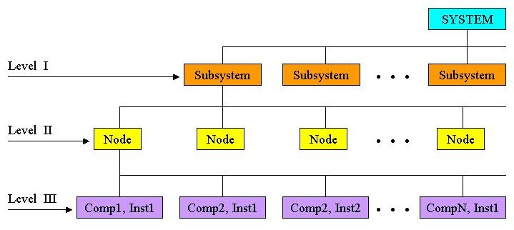
Figure 4-1 Levels of Compliance

Level I Compliance—Inter-Subsystem
Level I compliance addresses the requirements between subsystems (i.e., Robot to Robot, Robot to Controller, or Controller to Controller). The purpose of Level I is to support the interoperation of subsystems.

Level II Compliance—Inter-nodal
Level II compliance addresses the requirements between nodes (i.e., payload to payload, payload to on-board controller.) The purpose of Level II is to support the interoperation of nodes.

Level III Compliance—Inter-component
Level III compliance addresses the requirements between components (i.e., component to component). The purpose of Level III is to support software source code reuse.

requirements
This section defines the JAUS compliance requirements. All supported JAUS messages, including user-defined messages, shall be identified for the element (subsystem, node, or component) under test. For each supported message, the latency and timing tolerances shall be identified. An element is defined as compliant if all supported JAUS messages meet compliance rules defined in Section 5.1.

Compliance Rules
The compliance rules are defined as follows:

- All supported messages shall be explicitly listed for JAUS compliance of the subject JAUS element.
- All supported messages shall explicitly state the version of the RA.
- All supported messages shall follow the JAUS message conventions, definitions, formats, and messaging rules as defined in the RA.
- All identified latency and timing tolerances shall be met.
- All supported Inform messages shall respond to the corresponding Query messages.
- All supported Event Notification messages shall respond to the corresponding Event Setup messages.

Methods
Methods shall be developed by the organization measuring compliance.

Appendix A—Acronyms

DCP Document Control Plan
DM Domain Model
JAUS Joint Architecture for Unmanned Systems
JAUS WG Joint Architecture for Unmanned Systems Working Group
JCS JAUS Compliance Specification
RA Reference Architecture
SOP Standard Operating Procedure
UMS Unmanned Systems
WG Working Group

Appendix B—Reference Documents

[1] The Joint Architecture for Unmanned Systems, Compliance Whitepaper – Inter-
Subsystem Compliance Recommendation, 14 January 2004.

[2] The Joint Architecture for Unmanned Systems, Domain Model (DM), Volume I, Version
3.0, 03 December 2003.

[3] The Joint Architecture for Unmanned Systems, Reference Architecture (RA), Volume II,
Version 3.1 12 December 2003.

[4] The Joint Architecture for Unmanned Systems, Transport Protocol (TP), Draft being
developed, 2004.

